3. PLAN FOR COLLECTING / USING DATA
(For Virtual Shirt Try-On System)

A. Types of Data Collected

1. Shirt Image Data (Retailer Assets)
Transparent PNG images of shirts
Metadata: shirt name, category, dimensions

2. User Pose Data (Keypoints Only)
Collected temporarily from webcam feed using AI models (MoveNet / MediaPipe):
Shoulder points
Torso width
Arm positions
Scaling and rotation angles
Note: No images or videos are stored.

3. System Usage Analytics
Number of try-on sessions
Time and frequency of use
Popular shirt selections
Device/browser used

B. Data Collection Process
Data Type | Source | Method | Storage
Shirt Images | Retailers | Upload via Admin Panel | Cloud Storage / CDN
Pose Keypoints | User Webcam | Real-time AI inference | Not Stored
Analytics | System events | API events | DB (Mongo/Firebase)

C. Data Usage

Functional Usage
Align shirts on user's body
Improve AR fitting accuracy
Provide recommendations (future enhancement)

Business Usage
Help retailers understand which shirts engage customers
Evaluate platform performance
Optimize try-on accuracy

D. Ethical & Privacy Considerations
No webcam frames are saved
No biometric data stored
Only anonymized keypoints processed
Camera permission required before try-on
Follows GDPR/India DPDP Act guidelines

E. Dataset Requirements (For Future Enhancements)
Larger dataset of shirt designs from retailers
Keypoint datasets for training scaling models
Optional: Synthetic data for full-body try-ons

4. DESIGN DOCUMENTS
Includes:
✔ Architecture Diagram
✔ High-level design
✔ Low-level design
✔ Wireframes
✔ Database Schema

⭐ A. ARCHITECTURE DIAGRAM (Text Version)
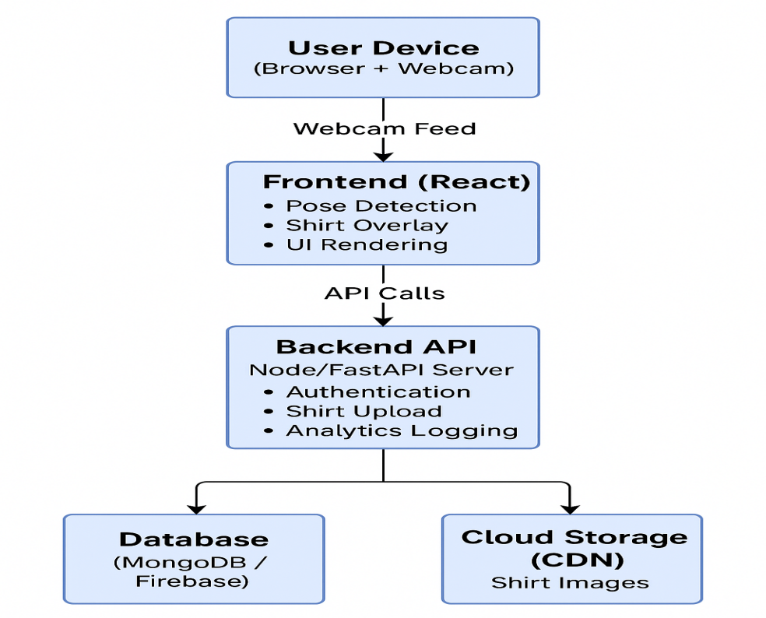

B. HIGH-LEVEL DESIGN (HLD)

Modules
Webcam Module:
Captures user feed
Handles camera permissions
Pose Detection Module
MediaPipe/MoveNet model
Generates keypoints in real-time
AR Overlay Engine
Scales and rotates shirt image
Aligns based on keypoints
Shirt Catalog System
Displays shirt list
Allows switching shirts
Admin Module
Upload images
Manage metadata
Analytics Tracker
Logs events
Tracks usage patterns

C. LOW-LEVEL DESIGN (LLD)

Key Components
Component | Responsibilities
CameraComponent.js | Start/stop webcam, resize canvas
PoseEstimator.js | Run pose model, return keypoints
OverlayEngine.js | Image transformation, drawing on canvas
ShirtSelector.js | UI interactions, load assets
AdminUpload.js | File validation, API upload
AnalyticsService.js | Track events, send logs to backend

⭐ D. WIREFRAMES (Text Representation)

1. User Try-On Screen
----------------------------------------------------
| Shirt Gallery | Live Try-On Canvas |
| [Thumbnail 1] | [User Webcam + Shirt Overlay] |
| [Thumbnail 2] | |
| [Thumbnail 3] | Buttons: [Snapshot] [Change] |
----------------------------------------------------

2. Admin Upload Panel
----------------------------
| Upload Shirt Image (PNG) |
| [Choose File] [Upload] |
| Shirt List: |
| - shirt1.png |
| - shirt2.png |
----------------------------

⭐ E. DATABASE SCHEMA

Users
Field | Type
user_id | String
email | String
role (user/admin) | String
created_at | Timestamp

Shirts
Field | Type
shirt_id | String
name | String
image_url | String
shoulder_width | Number
created_at | Timestamp

Analytics
Field | Type
event_id | String
user_id | String
shirt_id | String
event_type | try-on / snapshot / click
timestamp | Timestamp

